Using Powerpoint for drawing simple UMLs
- Open Microsoft Powerpoint application
- Create a new slide
- Select all contents of the newly created slide delete
- Go to Insert Table, select 1x3 table, resize as needed
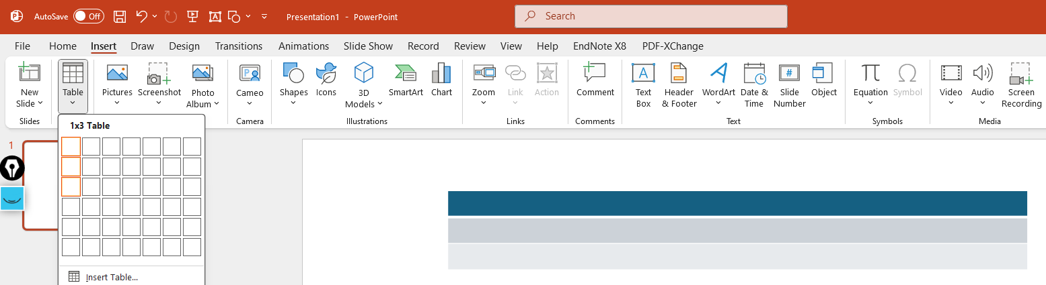
- Insert class name, fields and methods in the newly created table
- To create class relationship, go to Insert Shapes, go to subsection Lines or Flowcharts to choose appropriate shapes
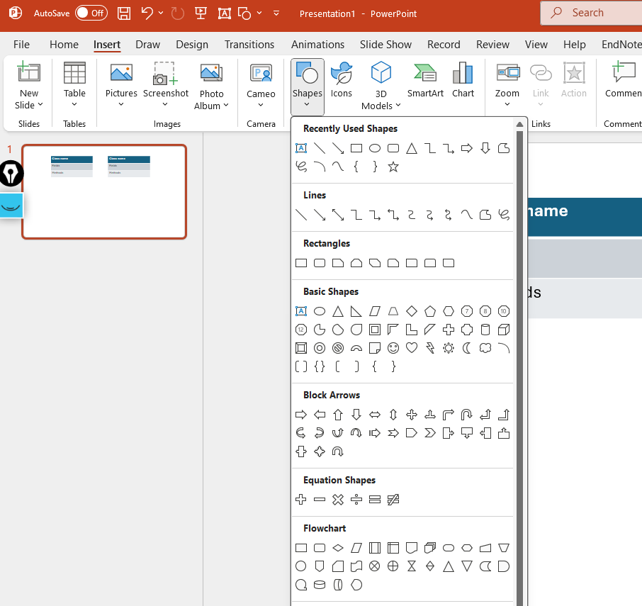
- To change the shape properties (shape fill, shape outline, line weigh or line style,…) select the shape Shape format and change the properties as needed
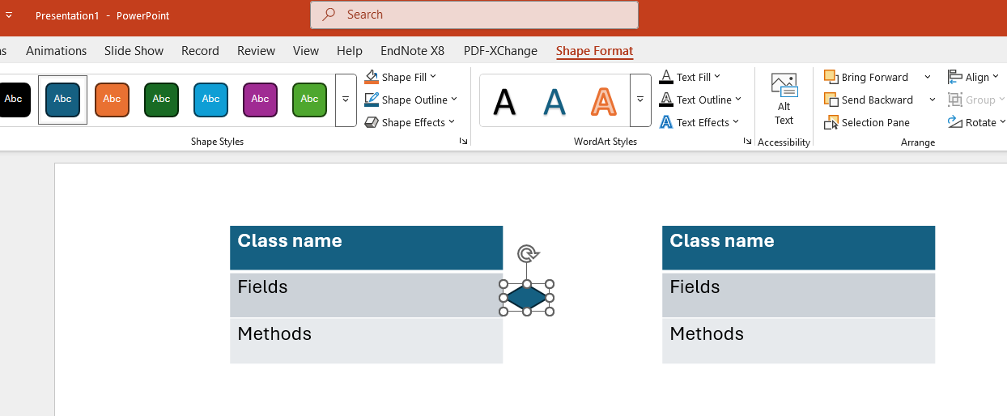
Hints: hold shift key while drawing a line to create a straight one

